Copper-nickel type with Au, Ag and platinoids genetically differentiated with intrusive of ultramafit. Standards of world value are Bushveld in South Africa, Sadberi in Canada, Norilsk in Russian. Representative object in the Central Asian region is the deposit of Kalatong, located on Chinese territory of South-west Altai.
As the world continues to develop and advance with new technologies, the need for natural resources increases in concert. Nickel, copper, and platinum-group elements (PGEs) are but a few of the critical materials that are in demand the world over.
1)Layered mafic intrusion
A layered intrusion is a large sill-like body of igneous rock which exhibits vertical layering or differences in composition and texture. These intrusions can be many kilometres in area covering from around 100 km² to over 50,000 km² and several hundred metres to over a kilometre in thickness. While most layered intrusions are Archean to Proterozoic in age (for example, the Paleoproterozoic Bushveld complex), they may be any age such as the CenozoicSkaergaard intrusion of east Greenland or the Rum layered intrusion in Scotland. Although most are ultramafic to mafic in composition, the Ilimaussaq intrusive complex of Greenland is an alkalic intrusion.
Layered intrusions are typically found in ancient cratons and are rare but worldwide in distribution. The intrusive complexes exhibit evidence of fractional crystallization and crystal segregation by settling or floating of minerals from a melt.
Ideally, the stratigraphic sequence of an ultramafic-mafic intrusive complex consists of ultramafic peridotites and pyroxeniteswith associated chromitite layers toward the base with more mafic norites, gabbros and anorthosites in the upper layers. Some include diorite, and granophyre near the top of the bodies. Orebodies of platinum group elements, chromite, magnetite, and ilmenite are often associated with these rare intrusions.
Mafic-ultramafic layered intrusions occur at all levels within the crust, from depths in excess of 50 km to depths of as little as 1.5 to 5 km. The depth at which an intrusion is formed is dependent on several factors:
- Density of the melt. Magmas with high magnesium and iron contents are denser and are therefore less likely to be able to reach the surface.
- Interfaces within the crust. Typically, a horizontal detachment zone, a dense, impermeable layer or even a lithological interface may provide a horizontal plane of weakness which the ascending magma will exploit, forming a sill or lopolith.
- Temperature and viscosity. As an ascending magma rises and cools, it becomes thicker and more viscous. This then restricts the magma from rising further because more energy is required to push it upwards. Conversely, thicker magma is also more efficient at forcing apart the wall rocks, creating volume which the magma may fill.
The Bushveld Igneous Complex covers a pear-shaped area in the central Transvaal. It is divided into an eastern and western lobe, with a further northern extension.
All three sections of the system were formed around the same time—about 2 billion years ago—and are remarkably similar. Vast quantities of molten rock from Earth's mantle were brought to the surface through long vertical cracks in Earth's crust—huge arcuate differentiated lopolithic intrusions—creating the geological intrusion known as the Bushveld Igneous Complex.
These intrusions are thought to predate the nearby Vredefort impact to the south, by some 30 million years.[2] The effects of these injections of molten rock over time, combined with the crystallisation of different minerals at different temperatures, resulted in the formation of a structure rather like a layered cake consisting of distinct rock strata, including three PGM-bearing layers, referred to as reefs. Large portions of the central area are covered by younger rocks.
The extrusions were emplaced over an early diabasic sill, outcrops of which are visible on the southeastern side of the Complex. These are typically greenish in colour and composed of clinopyroxene, altered to hornblende and plagioclase, and are regarded as the earliest phase of the Complex.
The Complex includes layered mafic intrusions (the Rustenburg Layered Suite) and a felsic phase. The complex has its geographic centre located north of Pretoria in South Africa at about 25° S and 29° E. It covers over 66,000 km2 (25,000 sq mi), an area the size of Ireland.
The complex varies in thickness, in places reaching 9 kilometres (5.6 mi) thick. Lithologies vary from largely ultramafic peridotite, chromitite, harzburgite, and bronzitite in the lower sections to mafic norite, anorthosite, and gabbro toward the top, and the mafic Rustenburg Layered Suite is followed by a felsic phase (the Lebowa Granite Suite).
The orebodies within the complex include the UG2 (Upper Group 2) reef containing up to 43.5% chromite, and the platinum-bearing horizons Merensky Reef and Plat Reef. The Merensky Reef varies from 30 to 90 cm in thickness. It is a norite with extensive chromitite and sulfide layers or zones containing the ore.
The Reef contains an average of 10 ppm platinum group metals in pyrrhotite, pentlandite, and pyrite as well as in rare platinum group minerals and alloys. The Merensky and UG-2 reefs contain approximately 90% of the world's known PGM reserves. About 80% of the platinum and 20% of the palladium mined each year are produced from these horizons

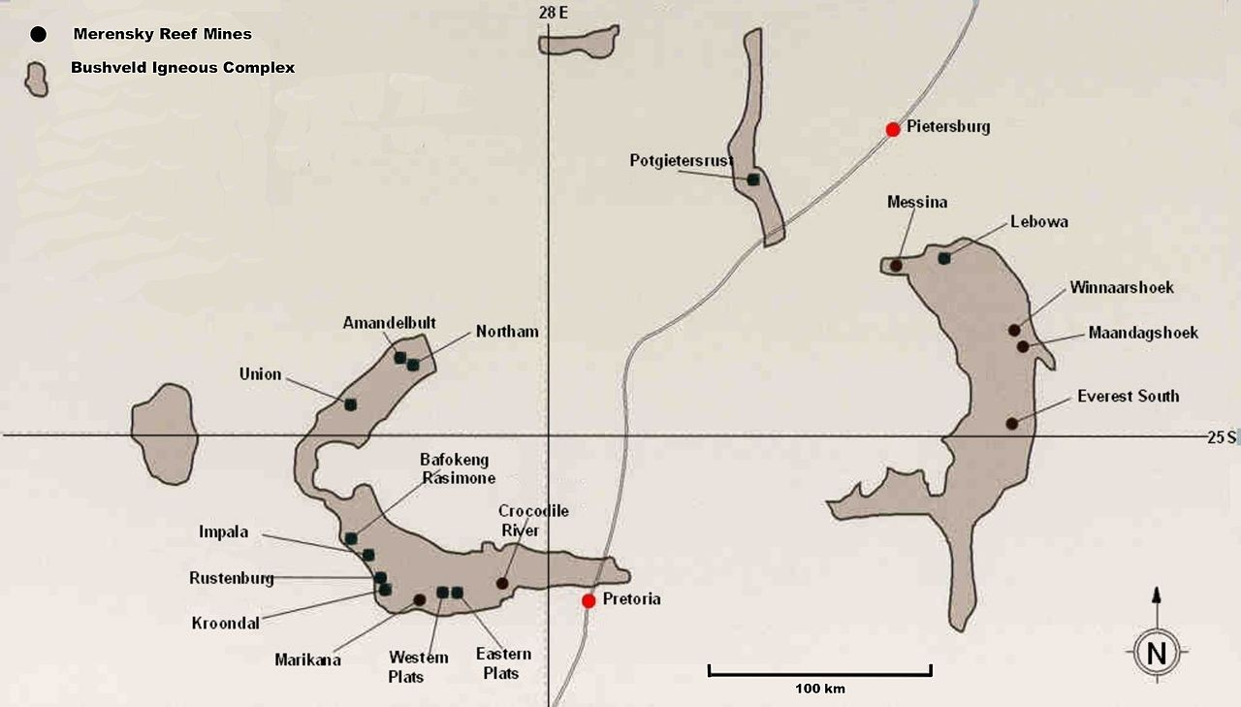

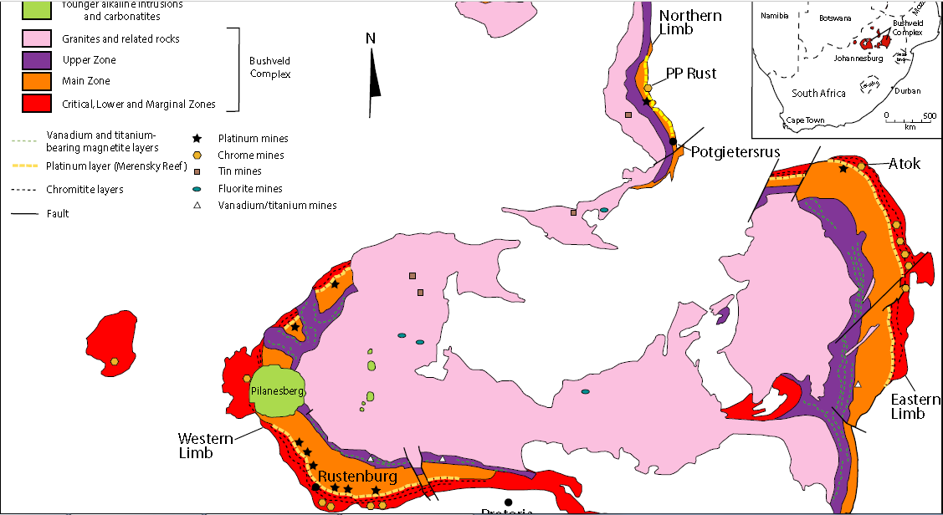

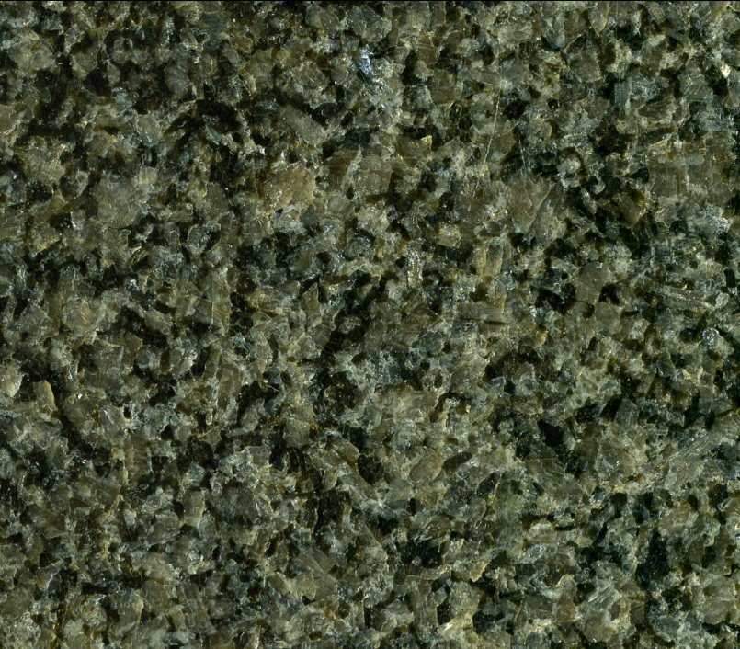

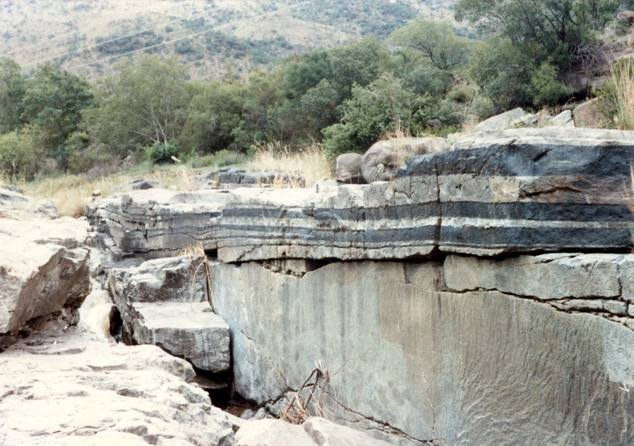

2. Mafic intrusion related to flood basalt

A flood basalt is the result of a giant volcanic eruption or series of eruptions that coats large stretches of land or the ocean floor with basalt lava. Flood basalt provinces such as the Deccan Traps of India are often called traps, after the Swedish word trappa (meaning "stairs"), due to the characteristic stairstep geomorphology of many associated landscapes. Rampino and Stothers (1988) cite eleven distinct flood basalt episodes occurring in the past 250 million years, creating large volcanic provinces, plateaus, and mountain ranges.^{[1]} However, more have been recognized such as the large Ontong Java Plateau,^{[2]} and the Chilcotin Group, though the latter may be linked to the Columbia River Basalt Group. Large igneous provinces have been connected to five mass extinction events, and may be associated with bolide impacts.
Flood basalts have tholeiite and olivine compositions (according to the classification of Yoder and Tilley). The composition of the basalts from the Paraná is fairly typical of that of flood basalts; it contains phenocrysts occupying around 25% of the volume of rock in a fine-grained matrix. These phenocrysts are pyroxenes (augite and pigeonite), plagioclases, opaque crystals such as titanium rich magnetite or ilmenite, and occasionally some olivine. Sometimes more differentiated volcanic products such as andesites, dacites and rhyodacites have been observed, but only in small quantities at the top of former magma chambers.

